Week 3 Assignment:

**Design Plan**

**Bukwild**

<https://www.bukwild.com/>

* I like the Homepage because each column becomes interactive once they're hovered over. It's also a very simple design which I really like, it's not full of unnecessary information, just short and straight to the point.
* I may replace the homepage's three columns with just one module for the text in the body of my redesign homepage.
* I really like the chunky form near the footer, and the size of the footer itself.
* I like the form and the footer for the homepage of the FESC redesign site.

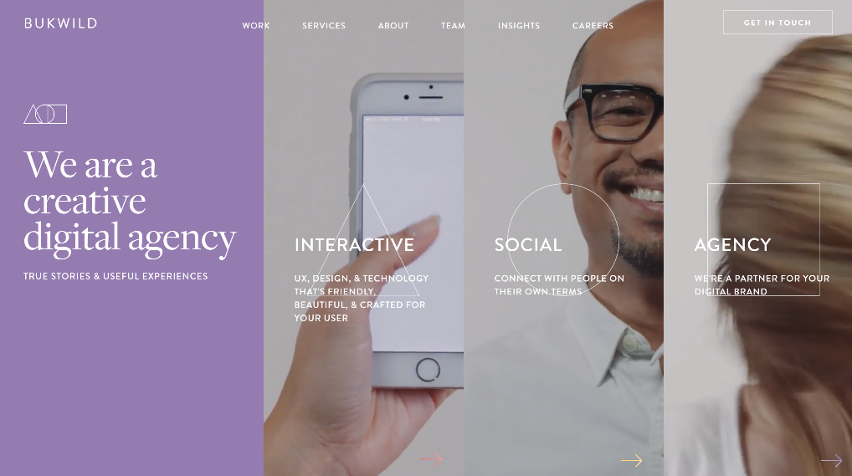

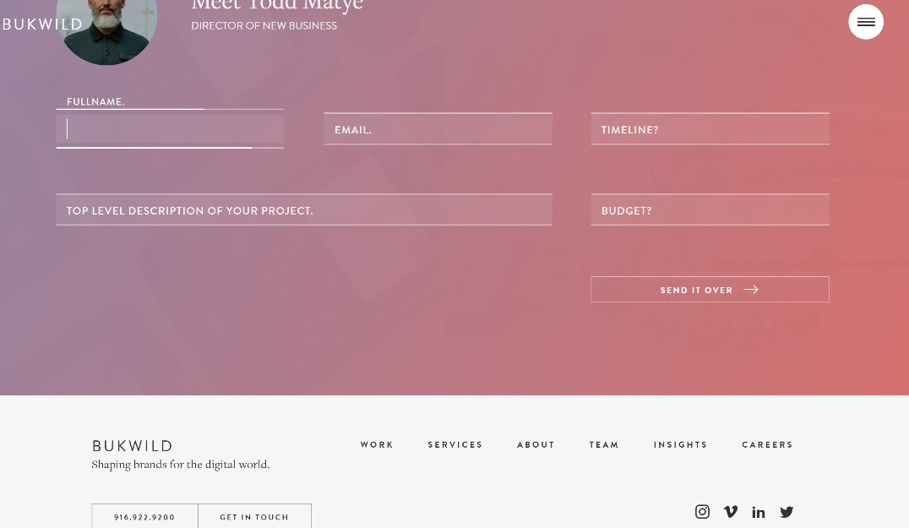

**Pogon**

<http://pogon.co/>

* This websites homepage has modules right on the homepage which we can click on and it directs us to new pages.
* I like this homepage design since it's not overbearing with information, it provides us with a glimpse of what we can visit if we wanted to.
* The header also gives us a quick sentence on what the website is about. I like this idea for my FESC homepage.
* I like the overall style of this homepage for the FESC's 'Energy Industry' site.

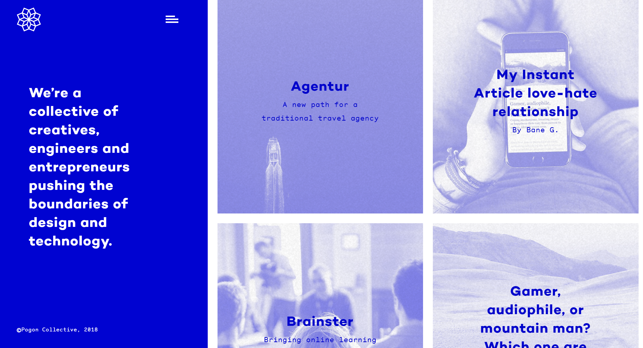

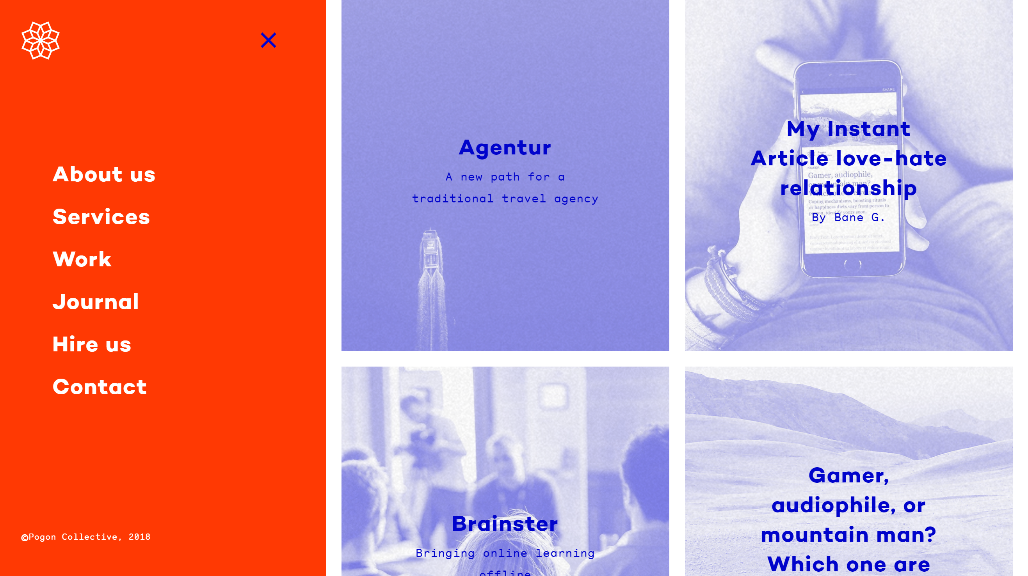

**Parallax**

<https://parall.ax/>

* I like the 'Contact Us' page from this site for the FESC's own 'Contact Us' page. It's simple, and I like that it feels like a postcard.
* I also like that the color scheme is kept simple and clean.

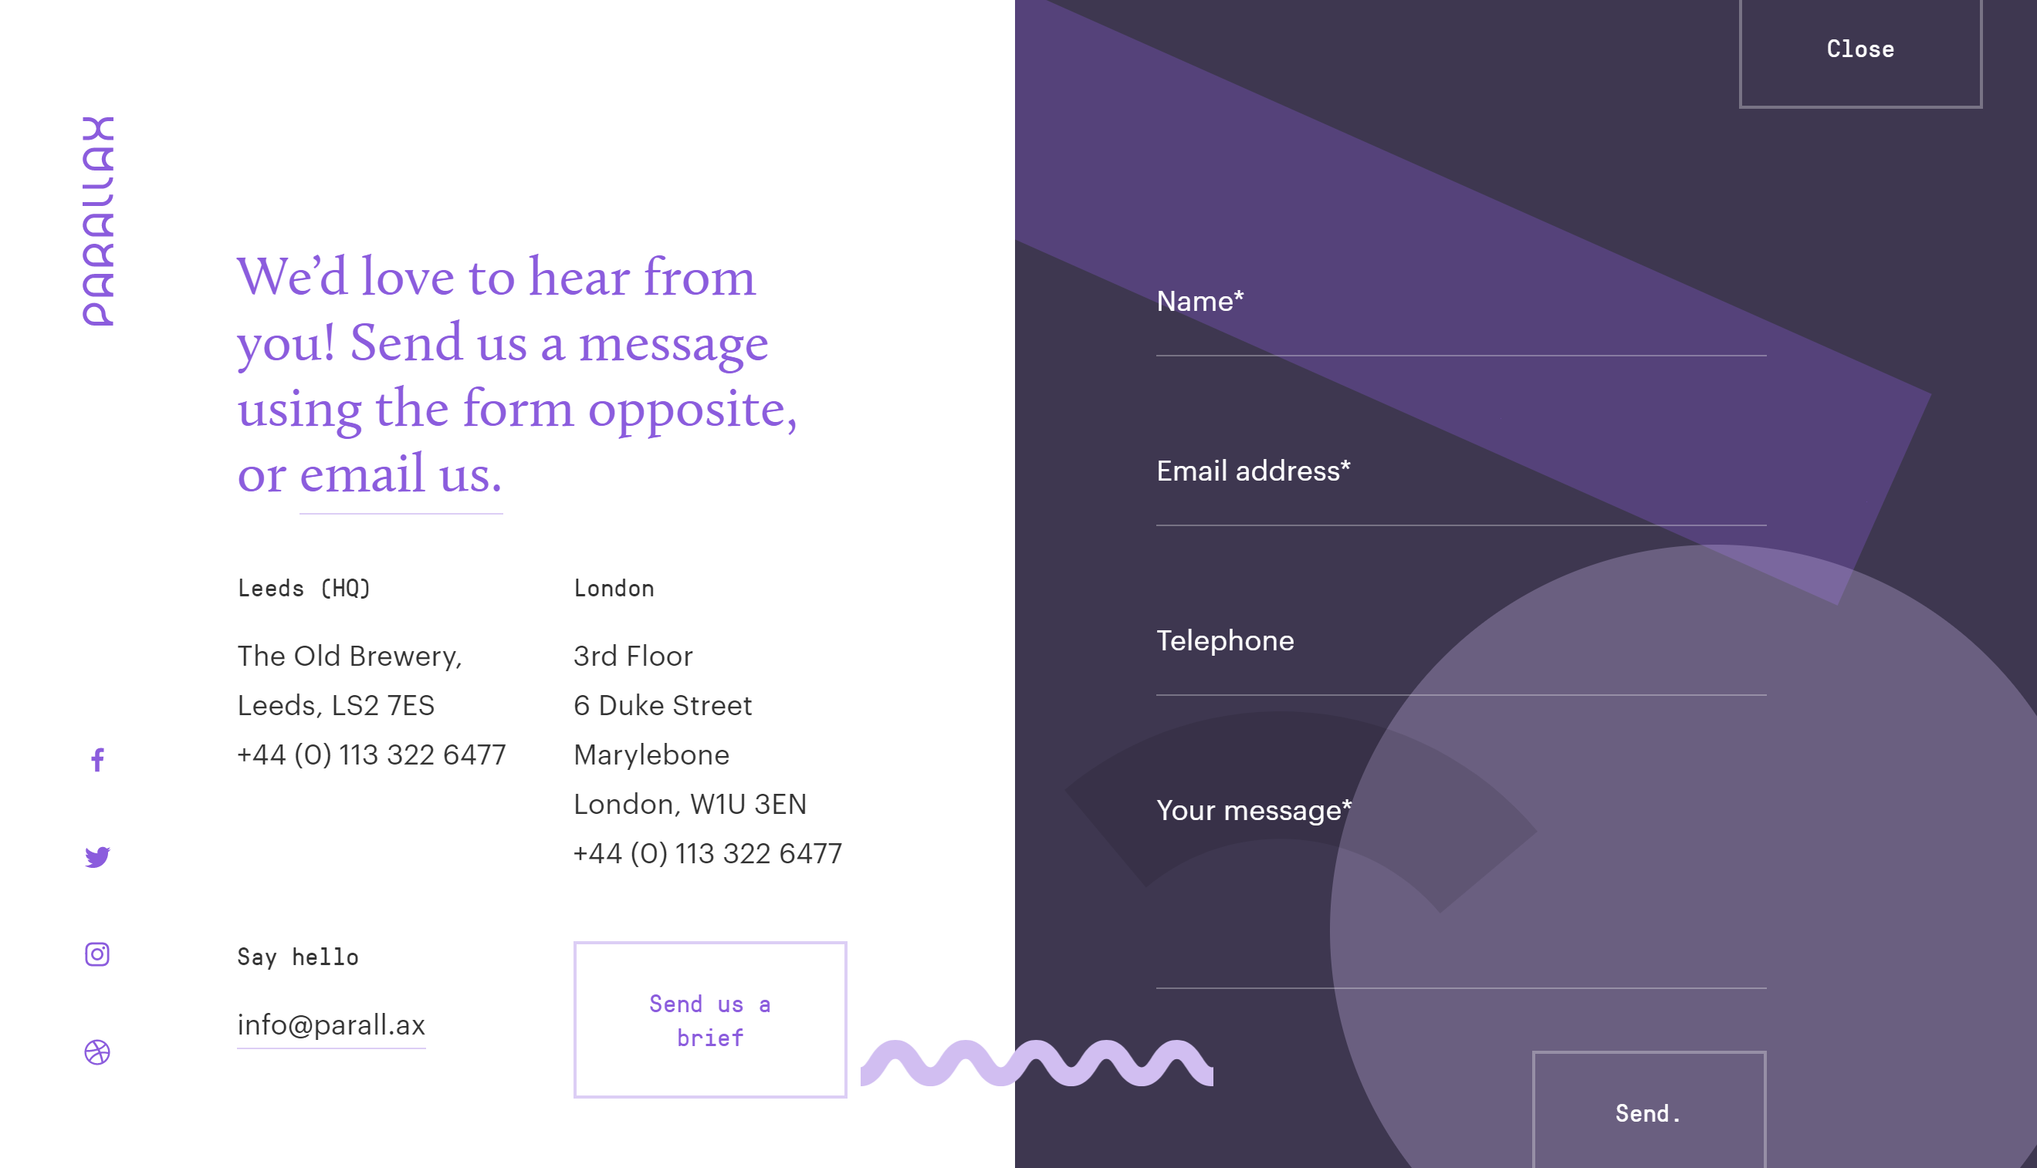

**Rekorder**

<http://rekorder.de/>

* I like the header for this website, and the fact that the header enlarges as a block when selecting one of the drop-down options.
* I'd use this sites header as inspiration for the header on the FESC redesign site.
* I'd change the logo position to the far left of the page and the navigation options to the right of the page.



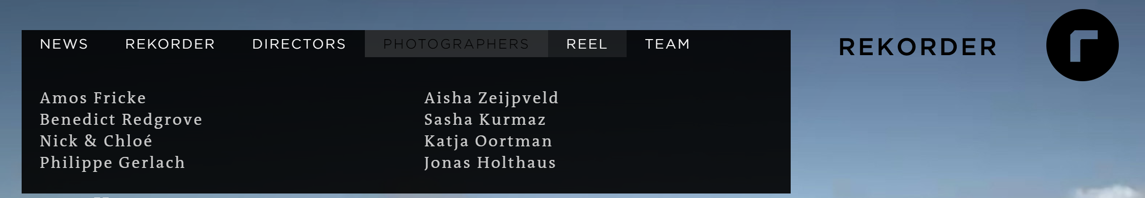

**Home Page**

* Module (repeated): Logo on Header section
* Module (repeated): Navigation Bar, also on Header section
* Module: YouTube Video
* Module: Text in the body
* Module: Newsletter Subscription Form
* Module (repeated): Footer: with Copyright & Contact Us Link

**Energy Industry**

* Module (repeated): Logo on Header section
* Module (repeated): Navigation Bar, also on Header section
* Modules (6): Squared, with Information on different energy sectors. These modules should link to outside sources, for visitors looking for additional information. This will be the main section for this page.
* Module (repeated): Footer: with Copyright & Contact Us Link

**Contact Us**

* Module (repeated): Logo on Header section
* Module (repeated): Navigation Bar, also on Header section
* Module: Social Media Buttons
* Module: Telephone & Address
* Module: Contact Us form
* Module (repeated): Footer: with Copyright & Contact Us Link

**General**

**Typography**:

Google Fonts:

* <link href="<https://fonts.googleapis.com/css?family=>**Anton|Questrial|Saira+Extra+Condensed**" rel="stylesheet">

**Headers**:

* font-family: 'Anton', sans-serif

**Body**:

* font-family: 'Questrial', sans-serif

**Newsletter Text:**

* font-family: 'Saira Extra Condensed', sans-serif

**Colors**

**Green**

* #006622
* rgb(0, 102, 34)
* hsl(140, 100%, 20%)

**Orange**

* #e68a00
* rgb(230, 138, 0)
* hsl(36, 100%, 45%)

**Gold-ish**

* #cc9900
* rgb(204, 153, 0)
* hsl(45, 100%, 40%)